**Neighborhood Play Sport**

**By**

**Shayan Sinha**

**Praytush Swamy**

**Adam Gillfillan**

**Patrick J. Feeney**

**CSC 554 Research Project**

**2013**

**Table of Contents**

**1) Introduction**

**2) Problem Statement**

**3) Task Domain**

**4) Target Users**

**5) Representative Scenarios**

**Introduction**

**It has been proven that physical activity increases one’s lifespan and has many healthy attributes like reducing stress and lowering risk of heart attack. We like sports and we believe others do too. We also find it difficult to know where to go locally to play team sports in a casual environment. Our application intends to link people with similar interests in the sports category. Think about us like - sports with no strings attached.**

**Surprisingly, in a study taken place in 2003-2006 only 15% of U.S. adults partake in exercise or partake in sports on an average day.**[1] **Consider that these same adults surveyed spent nearly 5 hours a day in front of the TV.**[2] **This same study also asked which sports were played when partaking in exercise and sports. The respondents reported 5% play Basketball and for Football, Baseball and Soccer were only approximately 1.5% each. In comparison, 30% exercise by walking.**[3] **We hope that our application will increase this paltry 1.5% in the sports mentioned above.**

**In our research we have found that one doesn’t need to be a world class athlete either.** You don't have to do high amounts of activity or vigorous-intensity activity to reduce your risk of premature death.  You can put yourself at lower risk of dying early by doing at least 150 minutes a week of moderate-intensity aerobic activity[4] **That is 2.5 hours a week. We think our application is novel, not obvious, and serves the community atmosphere.**

**Problem Statement**

**Daily physical activity for teens and adults can help offset obesity, hypertension, high cholesterol, heart conditions, gout, stoke and some cancers. Exercise has also been proven to improve mood and help one sleep better.**[5] **I know I could use better sleep, how about you? Sounds appealing, doesn’t it?**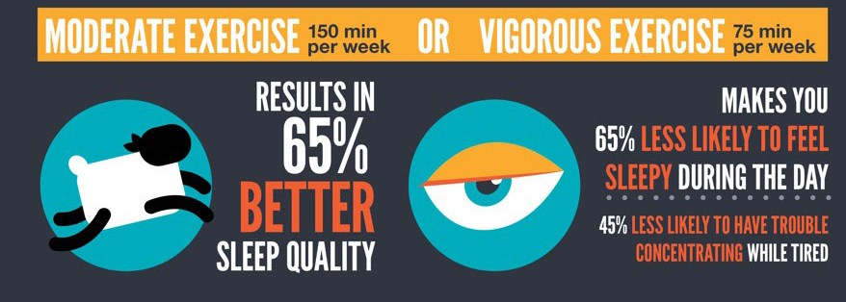

**Problem Statement continued**

**The overall problem at hand here is that there really are no places to join a team oriented sport without a major commitment. There is not a solid alternative to our application that is specific to sports. There are places like** [www.meetup.com](http://www.meetup.com) **but they are not exactly specific to sports. They are far reaching in their design for meeting up. The competition also does not have a map that helps browse locations of meetings. The application is a solution because it will offer a channel for adults to improve the low statistics mentioned above.**

**Task Domain**

**Let’s use an example. Suppose “Karen”, age 36, would like to play tennis once a week but doesn’t know anyone who plays tennis. Karen is also an above average tennis player. She is also a single mom and her schedule changes often, sometimes “last minute”. If she were on a team that had to meet at specific times she estimates that she would miss 30% or more of the games. This would make it not worth her time nor be fair to teammates. If she had a low cost solution where she could see tennis games in advance for several different times in her area, she would be more inclined to be more active per week.**

**Maybe “John”, age 25, wants to play baseball, even if it is just casual hitting and fielding. Now that he has the “Neighborhood Play Sport” app, he now knows when he can go play casual baseball. He likes using our app because there is no commitment and he has a hectic schedule too.**

**These people both have interests to play team sports that they cannot play by themselves. They both have hectic schedules which change often. This makes them not want to commit to a team sport on a deep level. The “Neighborhood Play Sport” app solves this problem. Now that they know where to go to get physical activity and more of it they are enjoying the health benefits that come along with physical activity. We think more adults will partake in physical activity. We believe people with use our app because in this WSJ article it was proven that playing sports for adults just one day a week increase pay.**[6] **A portion of our marketing will be trying to use this article in a cheeky way. For example, some type of marketing that states “Arent you curious to use our app and make more income?”.**

**The HCI concerns we will encounter because we are using a Google map on our app to explain where games are being played will be mapping, integration, and web navigation. All three will be the major HCI topics we have to be concerned with and address.**

**Target Users**

|  |  |  |  |  |  |  |
| --- | --- | --- | --- | --- | --- | --- |
| **We are targeting one of the most popular demographics in the U.S. and worldwide – the 18 to 50 year old crowd both men and women. According to Sports Business Daily the following demographic breakdown of sports fans in North America for MLB and NFL are:**[7]  **GENDER**  **MLB NFL** | | | | | | |
| Men | 58.8% |  |  | 60.2% |  |  |
| Women | 41.2% |  |  | 39.8% |  |  |
| **AGE** | | | | | | |
| Age 18-34 | 28.0% |  |  | 31.9% |  |  |
| Age 35-49 | 28.8% |  |  | 28.9% |  |  |
| Age 50+ | 43.1% |  |  | 39.2% |  |  |

**According to the above table it is pretty clear that there is sports interest from both men and women. We used just MLB and NFL because they are the most popular sports in America to play. See the website reference link for data on other sports. We have to use these statistics as a starting point because there are no firm statistics we could find on adult(s) playing sports outside of work/school.**

**This article**[8] **points out the fact that 18-34 year old demographic, the bulk of our overall target audience, earn and spend more than the 34-50 year old demographic. Albeit the 34-50 year old demographic are still an attractive audience.**

**The website “Statistics Brain” reports that 47% of adults meet the Physical Activity Guidelines for aerobic activity**[9]**. We think this lends credibility to our app and proves a market exists. We also believe that we can move this number higher with our app as it becomes more popular.**

**Representative Scenarios**

**Playing any sport – what happens**

Completive sports area and how it works

Casual sports area and how it works

1. <http://www.bls.gov/spotlight/2008/sports/>
2. <http://www.bls.gov/spotlight/2008/sports/>
3. <http://www.bls.gov/spotlight/2008/sports/>
4. <http://www.cdc.gov/physicalactivity/everyone/health/index.html#ImproveMentalHealth>
5. <http://www.cdc.gov/physicalactivity/everyone/health/index.html#ImproveMentalHealth>
6. http://blogs.wsj.com/economics/2008/06/30/study-for-working-adults-playing-sports-yields-higher-pay/
7. http://www.sportsbusinessdaily.com/Daily/Issues/2010/06/Issue-185/The-Back-Of-The-Book/Fan-Demographics-Among-Major-North-American-Sports-Leagues.aspx
8. http://www.bizreport.com/2007/03/study_target_youngwithmoney_demographic.html
9. http://statisticbrain.com/exercise-statistics/